Solution Architecture
Date | 10/07/2026
Name | SYED MOHAMMAD KHAJA
Project Name | Credit Card Approval Prediction
Maximum Marks | 5 Marks

Solution Architecture Diagram:
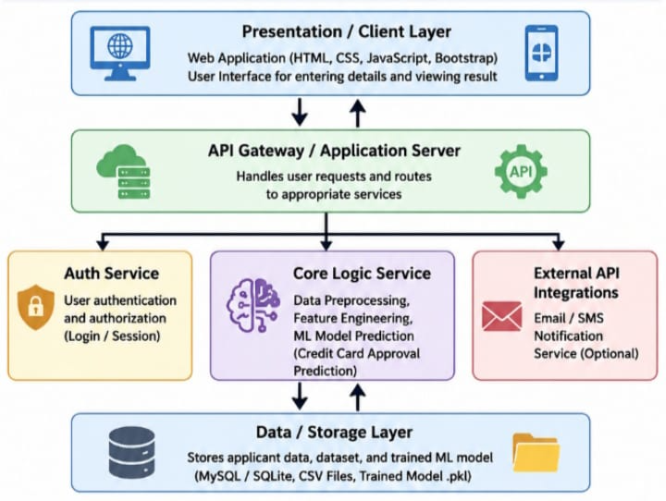

Component Description Table:
Component Name | Description / Role in Architecture | Technologies Used
Presentation Layer | User interface where applicants enter personal, financial, and employment details. Displays approval prediction and confidence score. | React.js, HTML, CSS, Bootstrap
API Gateway / Backend | Receives requests from the frontend, validates inputs, communicates with the ML model, and returns prediction results. | FastAPI / Flask, REST API
Authentication Service | Handles user login, authorization, and secure access to the application. | JWT, OAuth2 (optional), FastAPI Security
Core Logic Service | Cleans data, performs feature engineering, loads trained ML model, predicts credit card approval, and generates risk score. | Python, Pandas, NumPy, Scikit-learn, Joblib
External API Integrations | Sends email notifications or optionally retrieves applicant credit information from third-party services. | SMTP, Twilio, Credit Bureau API (Optional)
Database / Storage Layer | Stores applicant records, prediction history, trained model files, and datasets. | PostgreSQL/MySQL, CSV, Joblib (.pkl)

